Available online at [www.sciencedirect.com](http://www.sciencedirect.com/)



AASRI Procedia 3 (2012) 613 – 618

2012 AASRI Conference on Modelling, Identification and Control

Detection of Precursory Wave Using a Novel Sensor and Its Application to Earthquake Prediction

Liyu Huanga,*, Yingju Dua, Jianing Zhenga , Yuxiang Zhangb

*aSchool of Life Sciences and Technology, Xidian University, Xi-an 710071, China*

*bEarthquake Monitoring Center, Shaanxi Seismological Bureau, Xi-an 710068, China*

**Abstract**

A novel precursory wave detector by using liquid-suspension principle and super-low-frequency(SLF) sound signal detection technology in submarine is presented, then the device of earthquake precursory wave detection and the corresponding software are developed. The detection devices were placed respectively in Ziwu, Qianling and Louguan in Shaanxi Province, in more that a year, all the SLF-acceleration signals were recorded continuously in real-time; A contrast analysis was made between the abnormal precursory waves and the following earthquake events. The results show that the accuracy, sensitivity and specificity of this method in earthquake prediction are 72.08%, 39.06% and 81.73%, respectively.

© 2012 The Authors. Published by Elsevier B.V.

© 2012 Published by Elsevier B.V. Selection and/or peer review [under responsib](http://creativecommons.org/licenses/by-nc-nd/3.0/)ility of American Applied Science Research Institute

Open access under [CC BY-NC-ND license.](http://creativecommons.org/licenses/by-nc-nd/3.0/)

Selection and/or peer review under responsibility of American Applied Science Research Institute

*Keywords:* Precursor wave; earthquake; prediction

### Introduction

Being unclear of the mechanism of its forming and happening, earthquake prediction still remains a worldwide scientific problem. Since the concept of “precursor wave” was brought up by Kanamori[1], a lot of recording and analyzing work were carried out by investigators both in China and abroad. Although different

* Corresponding author. Tel.: +86-29-88202261 ; fax: +86-29-81891070.

*E-mail address:* [huangly@mail.xidian.edu.cn](mailto:huangly@mail.xidian.edu.cn)

2212-6716 © 2012 The Authors. Published by Elsevier B.V. Open access under [CC BY-NC-ND license.](http://creativecommons.org/licenses/by-nc-nd/3.0/) Selection and/or peer review under responsibility of American Applied Science Research Institute doi:10.1016/j.aasri.2012.11.097

earthquake examples were used, an approximate consensus on temporal and spatial distribution characteristics of precursor wave was reached[2-3].

A novel liquid-suspension precursor wave detector was realized based on a sound wave test technology based on the movement of the submarine and was deployed respectively at Ziwu, Qianling, Louguan of Shaanxi Province for more than a year to collect the ultralow-frequency acceleration precursor wave consecutively. Then the collected data were preprocessed according to certain rules. The abnormal signals and the occurrence of the earthquake were compared and the relationship between them was analyzed.

### Data collecting and preprocessing

* 1. *Precursor wave recording device*

A novel liquid-suspension principle was applied to develop a long-period three-axis signal sensor with high sensitivity, ultra low-frequency, and wide frequency band. The operating principle is that when the long- period precursor wave is detected, the subtle and slow fluctuation state will be captured by a conductive liquid and the mechanical signals will be transformed into electrical signals in three directions as the output of the sensor(see Fig. 1). The sensor is not affected by ground-to-air electromagnetic signals, which increased the bandwidth and signal-to-noise ratio of the recorded signals and provided reliable technique support for the live detection of precursor wave.

Based on liquid-suspension ultra low-frequency signal recording sensor mentioned above, EXI-3000 dynamic precursor wave recorder and MTROL-1.0 signal analyzing software were further developed, providing credible device and technique foundation for the following research. The appearance of the recorder is shown in Fig. 2.

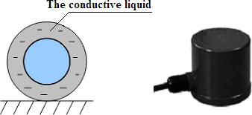

(a) (b)

Fig. 1 Liquid-suspension seismometer with ultra low frequency, (a) Schematic diagram; (b) Exterior of the seismometer

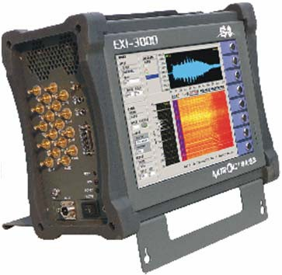

Fig. 2 EXI-3000 earthquake precursor wave recorder

* 1. *The geographical distribution of the recorder*

In order to locate the source of the precursor wave, two collection sites are needed at least. The signal recorders were deployed at three sites, namely Ziwu, Qianling(in Qian County), Louguan(in Zhouzhi County), to record precursor waves by Earthquake Monitoring Center of Shaanxi Earthquake Bureau. The geographic distribution of the recorders is shown in Fig. 3.

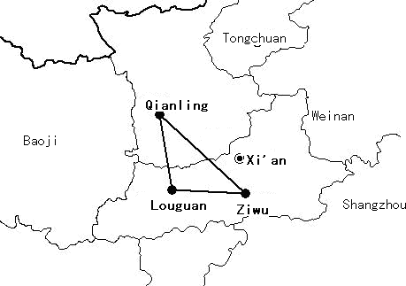

Fig. 3 The geographical distribution of the three collection stations in Shaanxi.

The recording was from May 25, 2010 to May 31, 2011, during which 372 days’ data were collected. Due to malfunctions of the devices, some data were missed for a part of time. In order to locate the epicenter by the time difference of the same precursor wave arriving at different stations, data from two stations are needed at least. Therefore, after eliminating the data collected at only one location, 283 days’ data are available for analysis; each day’s data are from two or three stations in two or three channels.

* 1. *Data preprocessing*

Normally, no abnormal wave appears in the recorded waveform and no earthquake happens several days later, which is shown in Fig. 4(a); if any precursor wave is recorded, the wave amplitude will significantly increase, as shown in Fig. 4(b). The recording channels are shown at top left in Fig. 4, at top right are the waveforms from all channels, at bottom left is the frequency spectrum of the signal from a single channel and at bottom right is its time frequency distribution.

In order to select the precursor waves suited to the requirements from 283 groups of data, some rules are defined according to previous studies and overall situation of the acquired data:

* + 1. when the amplitude of a wave exceeds 2.5×10-3 g, the wave will be considered as precursor wave, or abnormal wave;
    2. when the above-mentioned abnormality occurs at only one station, while the other one or two stations are under normal state, it will be considered as normal state;
    3. one day is the unit, if the precursor wave lies between two days, it will be regarded as belonging to the previous day; if more than one abnormal waves appear in one day, the one that has the largest amplitude will be considered as the precursor wave, while others are the incidental waves.

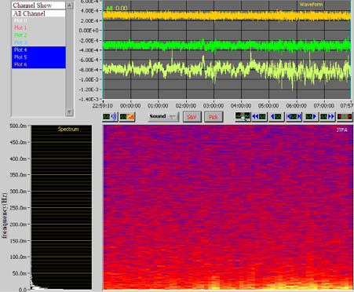 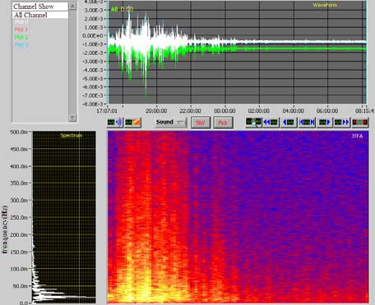

(a) (b)

Fig. 4 Recording interfaces under different signal states, (a) Normal state without earthquake following; (b) Abnormal state with earthquake following

According to the above-mentioned rules, 283 days’ data were analyzed carefully to select the precursor wave, 65 days’ data were up to the standard, namely 65 groups of precursor waves. After selecting the precursor wave, the epicenter could be possibly located by the time differences of the same precursor wave arriving at different collection stations. The specific steps are as follows:

1. To find the universal earthquake catalogue. The catalogue comes from the China Earthquake Networks[4-6]. Appearing moment of the precursor wave is defined as the initial time; all the earthquakes above 4.5 magnitude in China and 5 magnitude in China’s bordering countries within 72 hours after the initial time are summarized.
2. China’s bordering countries include Mongolia, Russia, Japan, Korea Peninsula, Philippines, Indonesia, Burma, Nepal, India, Pakistan, Afghanistan, Iran, Kyrgyzstan, Tajikistan, Kazakhstan, etc.
3. If there are two or more earthquake events after one precursor wave, the approximate direction of the epicenter could be determined by the time differences of the initial time of the precursor wave recorded at different collection stations, which is based on the fact that the precursor wave caused by the same earthquake will first arrive the collection station nearest to the epicenter.

For example, the abnormal waves collected on June, 2010. Two earthquakes happened in the following three days, which is shown in Table 1.

Table 1 The earthquakes happened in 72 hours after the precursor wave recorded on June, 2010

|  |  |  |  |  |  |
| --- | --- | --- | --- | --- | --- |
| Occurrence time | Magnitude(M) | Latitude(°) | Longitude(°) | Depth(km) | Reference location |
| 2010-6-9 0:09:23 | 4.5 | 44.4 | 83.2 | 10 | Jinghe, Xinjiang Province |
| 2010-6-7 0:42:42 | 4.8 | 33.2 | 96.3 | 10 | Yushu, Qinghai Province |

The precursor wave at Qianling is ahead of that at Ziwu, as shown in Fig. 5, therefore it could be deduced that the epicenter is nearer to Qianling, at which the precursor wave arrives first, and the epicenter should be

on the northwest of the collection stations. Because of the fact that Yushu, Qinghai province is on the southwest of the collection stations, it could be confirmed that the precursor wave was from the earthquake in Jinghe County of the Bortala Mongolia Autonomy, Xinjiang Uigur Autonomy region on June 9.

1. 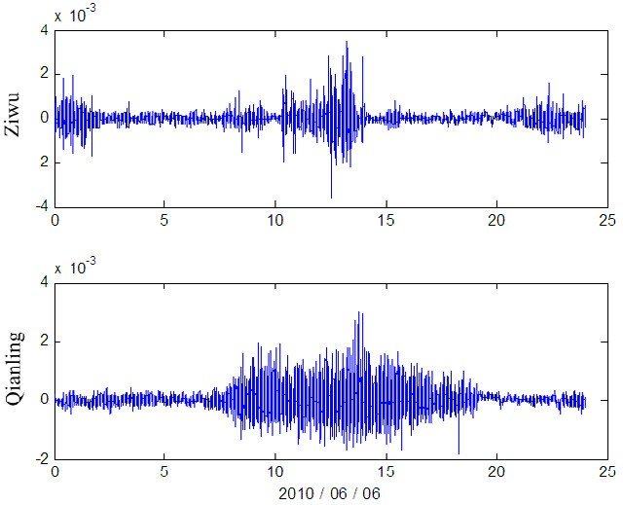If more than two earthquake events are identified according to the time differences, the one with the greatest magnitude should be considered as the one which cause the precursor wave.

Fig. 5 The precursor waves recorded at two collection stations on June 6, 2010

### Method and result

According to the above-mentioned rules, the collected data are divided into four categories: the first category includes the 44 groups of data in which precursor waves are followed by earthquake events within 72 hours; the second includes the rest 21 groups of data, in which no earthquake events follow the precursor waves within 72 hours. In the data of 218 days in which no precursor wave appears, some earthquake events happen as well, therefore the third category includes the 102 days’ data with no precursor wave or earthquake, and the fourth includes the 116 days’ data with earthquakes but no precursor wave.

Three indexes are commonly used to evaluate the prediction results, including accuracy, specificity and sensitivity. The definitions are as follows:

*accuracy*



*TP TN TP FP TN*

# 100%

## *FN*

*(1)*

*sensitivity*



*TP* 100%

*specificity*

## *TP FN* TN

# 100%

*(2)*

## *TN FP*

*(3)*

True positive(TP) stands for the first category, fake positive(FP) stands for the second category, true negative(TN) stands for the third category, and fake negative(FN) stands for the fourth category. Obviously, in our study, TP = 25, TN = 179, FP = 40, FN = 39. Therefore, the values of the three indexes are: accuracy 72.08%, sensitivity 39.06%, and specificity 81.73%.



It could be concluded from the results that although the specificity is relatively high, the accuracy and sensitivity are somewhat low with the intuitionistic classification and prediction method. Modern signal processing and pattern recognition method will be applied in analyzing the precursor wave, which could further increase the accuracy.

### Discussion

Previous research has shown that plenty of tiny dislocation or rupture emerges in the epicenter and the neighboring medium shell before a great earthquake happens. Connection of a large number of tiny rupture and further development of the dislocation will lead to bigger rupture and greater dislocation. Before the main rupture, there will be a longtime creep and grind of the fault, the crack becomes unstable and expand, which eventually cause an earthquake. Before an earthquake, there will be a slow and steady expansion and unceasing secondary rupture or tiny rupture of the fault. The creep and grind of the rupture and fault may be the origin of the precursor waves, which have close relationships with the main rupture of the earthquake.

There are still many problems worthy of further improvement and discussion:

1. Under the support of earthquake monitoring center of Shaanxi Earthquake Bureau, earthquake precursor wave recording devices based on liquid-suspension principle were placed at Ziwu, Qianling, Louguan respectively and continuous signal recording had been implemented for over a year. Comparing with the propagation speed of the precursor waves, the three data collection stations are too close to each other, which has a certain impact on locating the epicenter. Accordingly, recording devices were relocated in Gansu, Henan, Sichuan and Shaanxi, which are relatively far away from each other. The new data recording process has started from July 21, 2011.
2. Due to lacking a solid theoretical basis about the amplitude of the precursor wave, the magnitude that might trigger it, and the epicenter locating problem, combined with existing research results and the actual situation, several standards are put up before preprocessing. The user-defined standards may affect the final prediction accuracy.

Although there are many shortcomings in this study, precursor waves with ultra low-frequency are recorded by self-designed devices, and a new signal processing algorithm and classification algorithm are applied. Certain conclusions are obtained for the reference of fellows in China or abroad.

### Acknowledgements

This work is financially supported by the National Natural Science Foundation of China under grant NO.

81071221 and NO. 31271063.

### References

1. Kanamori H, Cipar JJ. Focal process of the great Chilean earthquake on May 22, 1960. Physics of the Earth and Planetary Interiors 1974; 9:128-136.
2. Kizawa T. Gravimeter recording before and after great earthquake. Abroad Earthquake 1992; 1: 19-41.
3. Chen D, Luo R, Liu G. Preliminary discussion on the classification of anomaly patterns of ground tilting and its problems concerned. Crustal Deformation & Earthquake 1985; 5:185-209.
4. Information on <http://www.ceic.ac.cn/>
5. Information on <http://www.csndmc.ac.cn/newweb/index.jsp>
6. Information on <http://www.csndmc.ac.cn/newweb/catalog_direct_> link.htm